1. 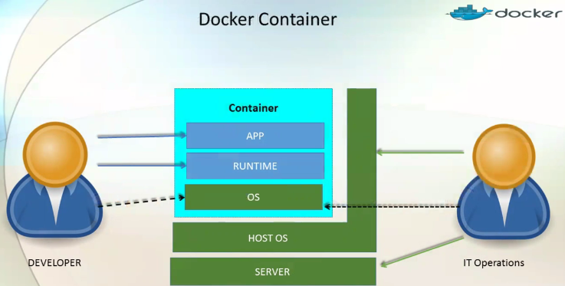  
   There is subset of components shared b/w Developers and IT Operations and that is **Container OS** and that is Docker Container.   
   Basically, container OS is coming from host OS. Container OS is not complete set of OS. Container OS contains only those files/binaries required to run an app and rest of the binaries, libraries, and components only reside with Host OS. So this becomes very **lightweight**. So container takes less time for the followings
   1. To spawn (To create a new one).
   2. To turn on/off
   3. To move/migrate.
2. Top of Container OS is the component 🡺 RUNTIME which allows container to run the app. The complete daemon that is running on top of OS is called Docker Engine.
3. On Top of that Docker Engine, we have a number of app.
4. Let’s say we have DB in container 1 and Web Server in Container 2 and Middle Ware in Container 3.
5. 